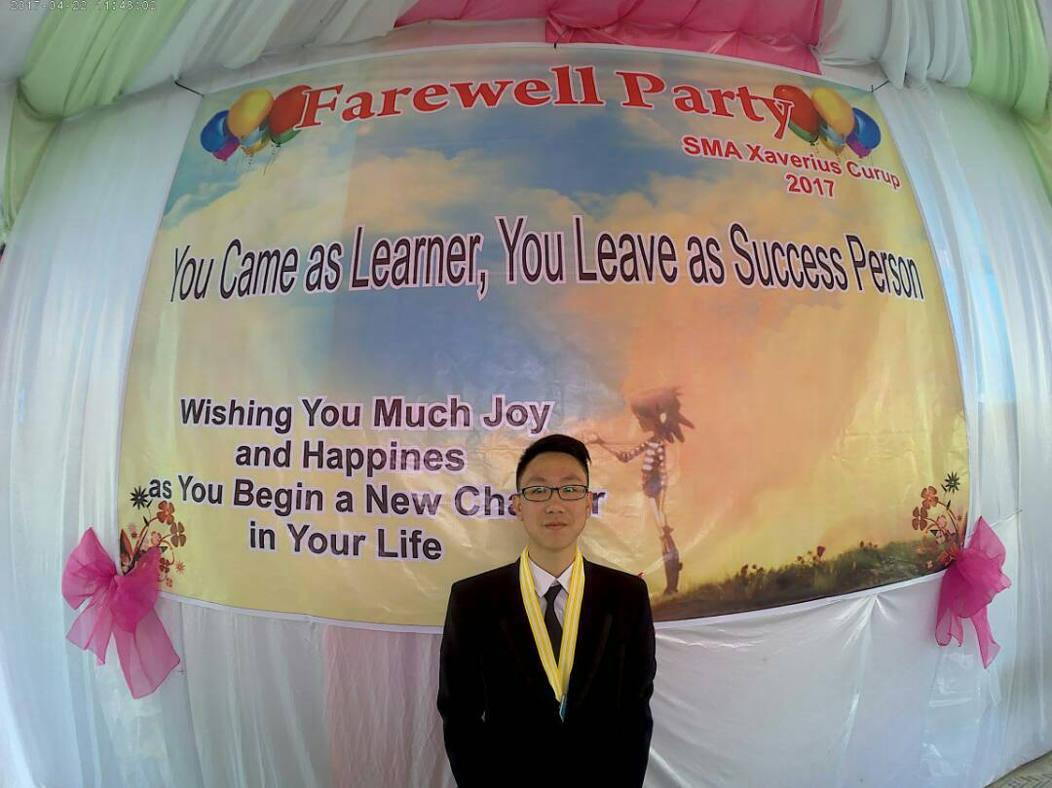
CALVIN JONATHAN CHANDRA
J.L D.I. PANJAITAN NO.70 RT 001/001, Curup, Rejang Lebong, Bengkulu
(081)279795770, calvinjonathan090@gmail.com

EMPLOYMENT OBJECTIVE
A career in Information System, specifically in the areas of business analysts that will optimally utilize to know the development of a business in the company to grow more in the future.

EDUCATION
INSTITUT TEKNOLOGI HARAPAN BANGSA Augustus 2021
Bandung, Indonesia
Sarjana Sistem Informasi, Concentration: Database Administrator
GPA: 3,05

Certiplus Program November 2020 December 2018
at ITHB Career Resource Center
Completed a series of professional training in computer, communication, leadership, simply accounting, entrepreneurship and career planning skills

SAP University Alliance Program
at ITHB Career Resource Center
Completed the SAP ERP Configuration with GBI June 2019
Completed the SAP Introduction to SAP ERP with Global Bike Incorporation May 2019

SMA XAVERIUS CURUP, Rejang Lebong, Indonesia June 2017

EXPERIENCE
PHOTOGRAPHY CANTIK STUDIO, Bandung December 2017 - Present
A photograph studio and editor in Bandung that gives service in renting, editing, and printing photos of family, friends, couples, and The Army
Production Plan
Worked, led, and controlled the quality of the product to maximize the output to photo
- Created numerous of valuable market relationships with customer.
- Exceed the daily target given by the company’s executives and made double the expected profit to the company

ADDITIONAL INFORMATION
- Proficient in the following technologies:
- Operating Systems: Windows, Mac, and Linux
- Office Suite: Microsoft Office (Word, Excel, Powerpoint, Visio, and Access)
- Databases: MySQL (2017)
- Application Development and Programming Technologies : Java, Eclipse, Adobe XD (2018)
- Web Application and Development: HTML, HTML5, CSS, JavaScript (2018).
- Participant in CEO Talk “Open Data Integration and It’s Security” (November 2018); with speaker Mr. Sutedjo Tjahjadi – Managing Director Datacomm Cloud Business of PT. Datacomm Diangraha.
- Participant in CEO Talk “Perkembangan Teknologi Informasi di Era Financial Technology” (March 2018); with speaker Mr. Armand Wahyudi Hartono – Deputy President Director of PT. Bank Central Asia, Tbk.
- Member of Logistics Division of Community Service of Students of Association in SMA Advent Bandung; Prepared equipments for the seminar given in SMA Advent Indonesia Bandung (April 2018).
- Member of HBR (Harapan Bangsa Runners); HBR is a running community based on campus (Augustus 2017 – Present).

